 |  | Broward county Honor Society- August/ December
 | BCHS NEWSLETTER
Ms. Santiago, students activities liaison |  |  |  |  |  | (954) 955-3163 I xenia.santiago@browardschools.com I  https://browardcountyhonorsociety.weebly.com
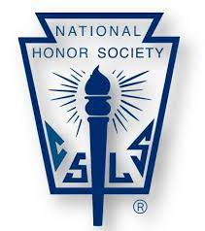  Welcome to the BCHS bulletin!  Hello everyone! This is your corresponding secretary Alejandro Leon keeping you updated with all things regarding BCHS. Throughout the year, it has been my highest honor to serve as one of your officers. Working with an amazing group of peers and meeting you all at the monthly meetings has been grateful. I am thankful for all the work you make to brighten this organization and build the foundation for the future.  As we culminate the 2022 season, it’s with great enthusiasm that I’m announcing the delivery of the first newsletter of the year! As you read along, you’ll find out ways in which different school chapters are making a difference. That being said, we hope you continue to have an amazing time while leading by example in your communities. |  |  |  |  | GETTING READY FOR YOUR NEXT STEP  The BCHS convention for the 2022-2023 school year will be on March 30^{th,} 2022, at Pompano high school. This will be an event to finalize the journey we’ve started and begin a new one. Make sure your school has taken on every project by the end of February so that reports can be written on time for the nomination deadline in the categories provided by the National Association of Secondary school principals. |  |  |  | Blanche Ely high school:  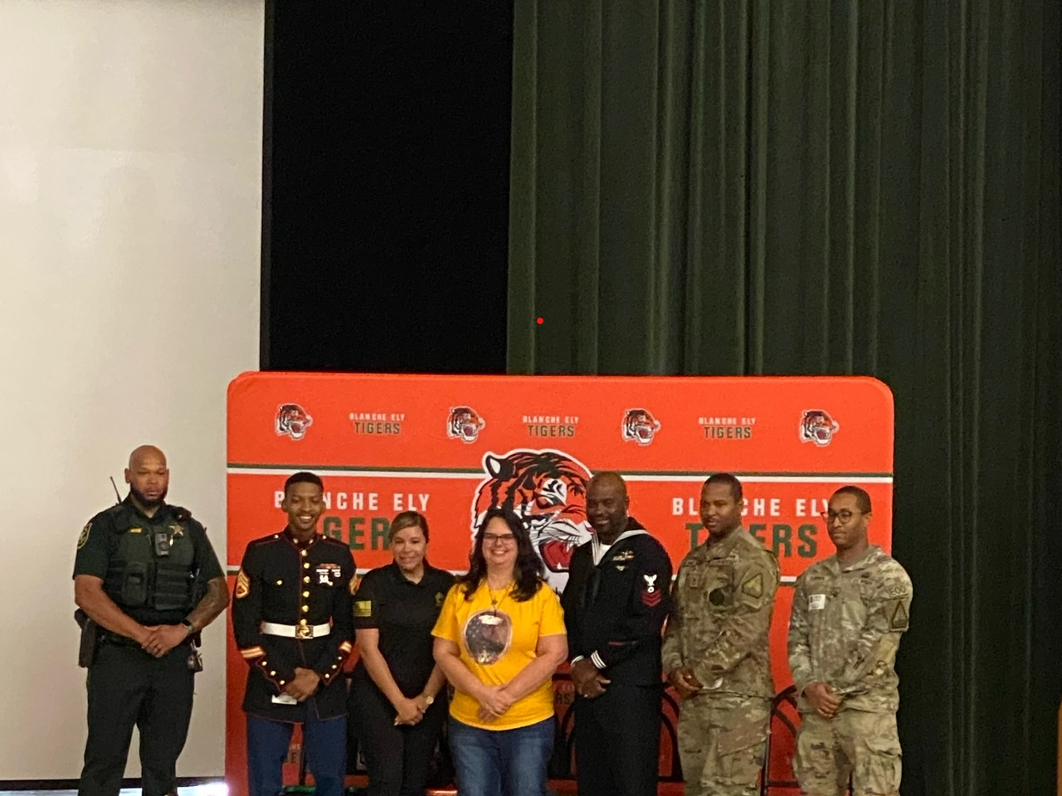  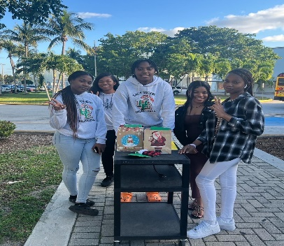
 |  |  |  |  | UPCOMING EVENTS  MS Brain Brawl- January 21st, at Seminole  Brain Brawl finals- February 15th, at Plantation HS  Dodgeball tournament- February 4th, 2023, at Monarch high school |  |  |  | “We did not come here to fear the future. We came here to shape it”  -Barack Obama

 | BCHS Blog
 |  |  |  | Pompano Beach high school:  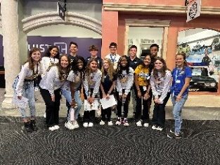  Chaperoning elementary school kids  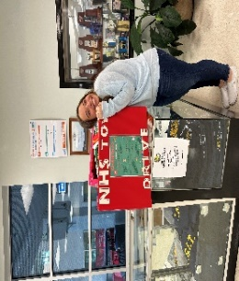  Collecting toys for Joe DiMaggio |  |  | Coral Glades high school:  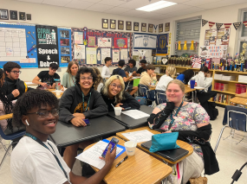  NHS Ice Cream Social  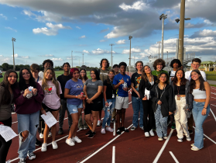  “Walk for a cause” event.
RECENT HIGHLIGHTS
NHS officer workshop  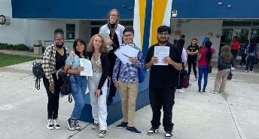  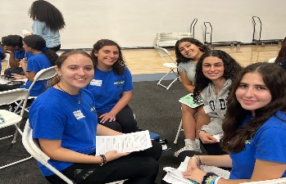 |  |  |  | 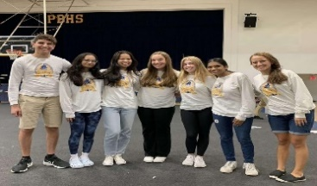  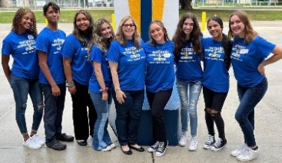 |  |  |  | Getting to know the president: Shishon Kumarasri  Q1: What do you like the most about your officer position  The various interactions and people he learns from  Q2: What is one thing BCHS has taught you?  The organization and structure he is able to apply to other areas of his life  Q3: What is your favorite thing about BCHS?  The experiences he’s lived and the lessons he’s learned.
Organizations to look at for service opportunities: |  |  |  | -Joe Di Maggio children’s hospital: One of the region’s leading pediatric hospitals.  -Harvest Drive Florida: To provide food and other necessities to Broward County school families.  -Joshua’s heart foundation: To fight against global hunger through the community service of young people.

